Assignment-24.5:

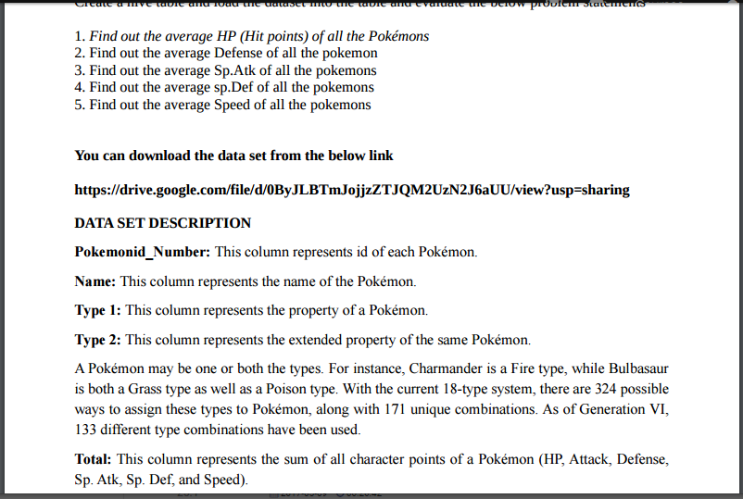

A table named Pokémon is created and the data is loaded into the table. The content of the table is described in the below screenshot.

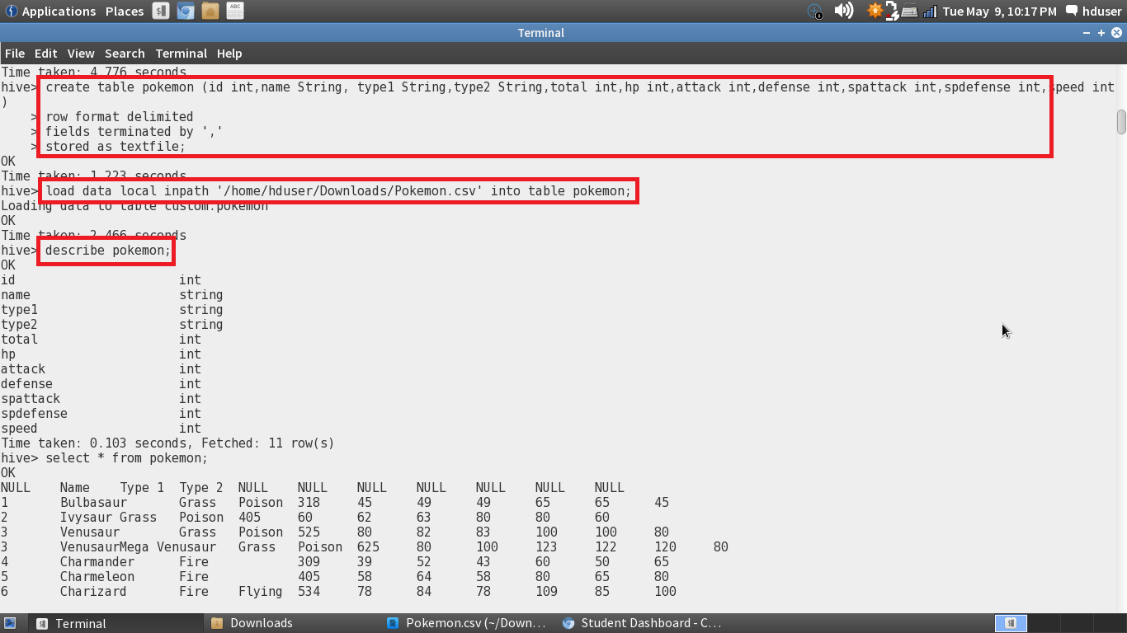

1. Find out the average HP (Hit points) of all the Pokémon

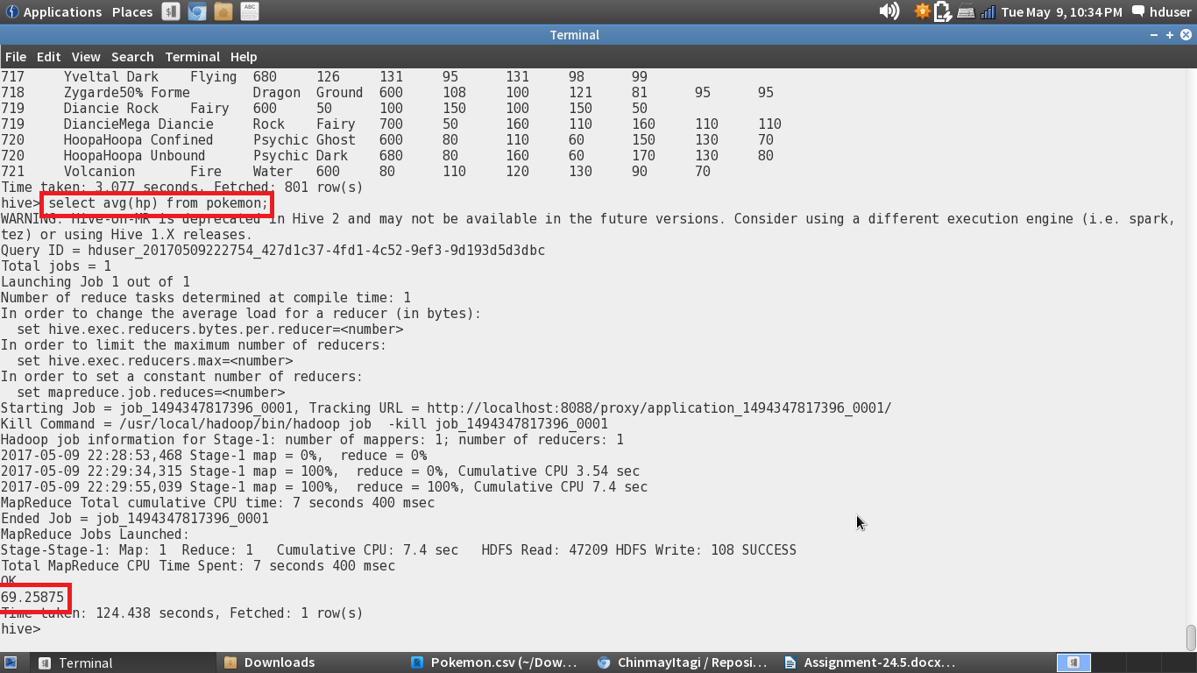

2. Find out the average Defense of all the Pokémon

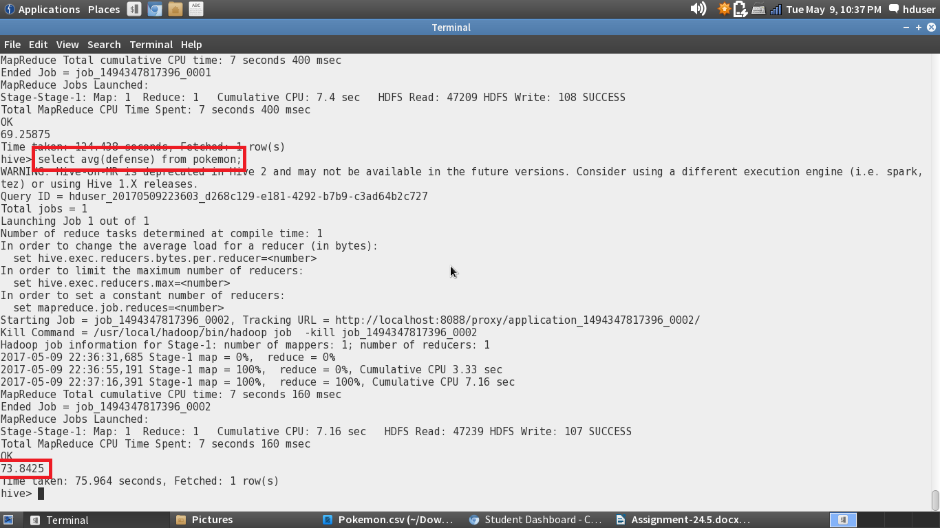

3. Find out the average Sp.Atk of all the Pokémon

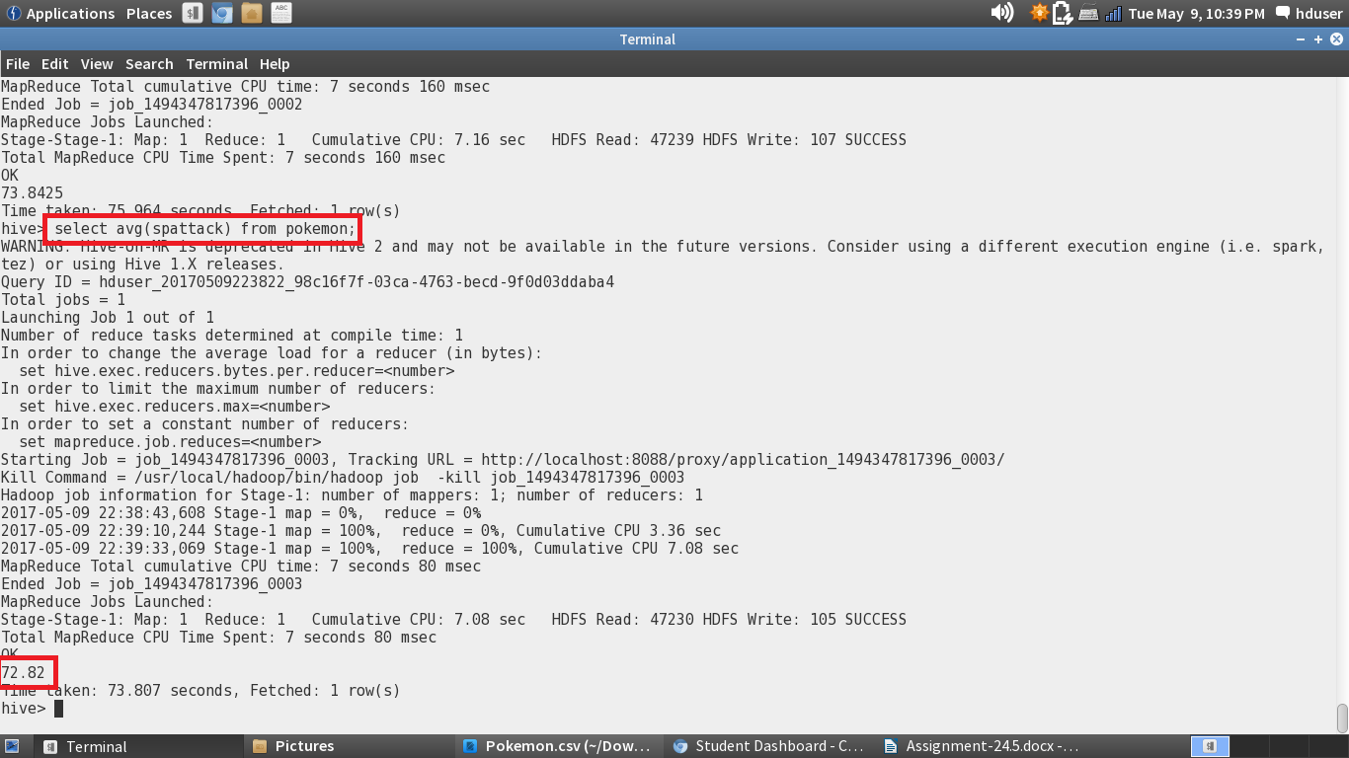

4. Find out the average sp.Def of all the Pokémon

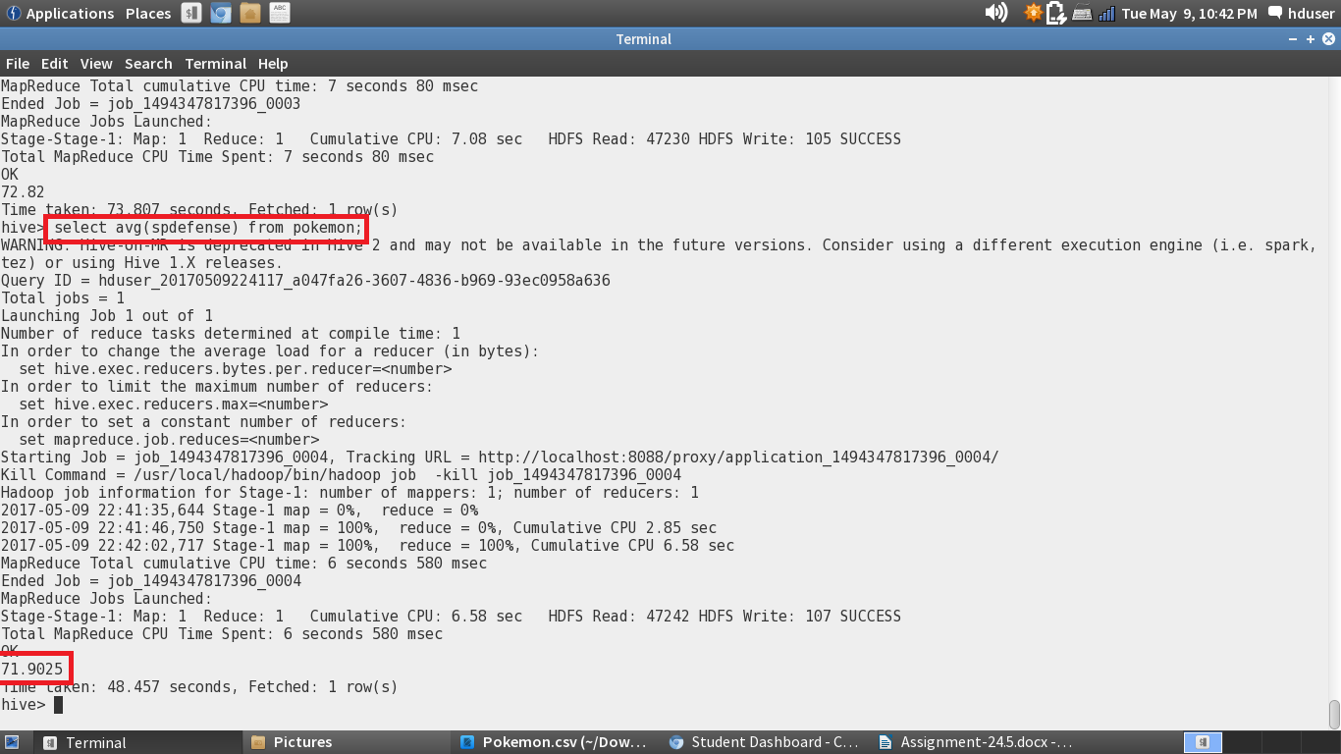

5. Find out the average Speed of all the Pokémon

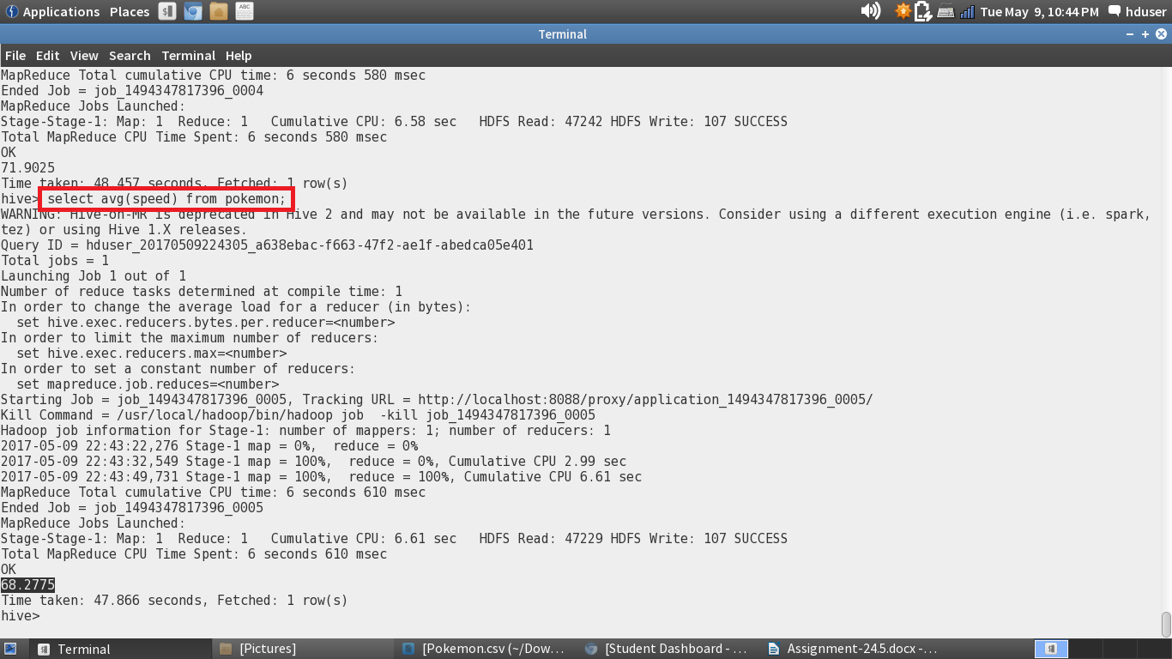

All of the above problems are solved using this command:

**Select avg (column_name) from pokemon;**

The average function is used here.